**VIETNAM NATIONAL UNIVERSITY HO CHI MINH CITY**

UNIVERSITY OF TECHNOLOGY

FACULTY OF ELECTRICAL AND ELECTRONIC ENGINEERING

**DEPARTMENT OF ELECTRONICS**

---------------o0o---------------



**TEMPERATURE & HUMIDITY   
MEASUREMENT**

**PROJECT REPORT: EMBEDDED SYSTEM**

**STUDENT NAME: Văn Thiên Lâm**

**STUDENT ID: 2151110**

**HỒ CHÍ MINH CITY, MAY 2025**

**I. HARDWARE SELECTION**

The system is designed around the ATmega8A microcontroller, connected to two DHT11 sensors and an I2C-interfaced LCD for displaying data. A 5V power supply is stabilized using a voltage regulator and filter circuit, providing clean power to all components. Peripheral components like the reset button and 16 MHz crystal ensure stable clocking and reliable startup for the MCU. Each hardware element is selected based on functionality, availability, and cost-efficiency for the application's scope.

**Microcontroller Unit (MCU):**

The **ATmega8A**, a low-cost 8-bit AVR microcontroller, is selected as the core processor. It features **23 I/O pins**, built-in interfaces like SPI, TWI (I2C), and USART . It operates at frequencies up to **16 MHz**, which is more than sufficient for reading low-frequency sensors (about 1 Hz) and updating the display. Programming is straightforward using **AVR-GCC or Arduino IDE**, thanks to strong community and toolchain support . With **8KB of Flash memory**, it easily accommodates firmware for a small-scale sensor display system. It also operates in a wide voltage range (2.7–5.5V) . Compared to more expensive MCUs like the ATmega328P (32KB), the ATmega8A is cost-effective and capable for this task.

**Figure 1**. ATmega8A I/O pin mapping

**Peripherals:**

* **Reset button (SW1):** Connected to the RESET pin with a pull-up resistor, this allows manual MCU reset and bootloader programming.
* **16 MHz crystal oscillator:** Provides a stable system clock. Paired with two ~15–22 pF capacitors, it ensures precise timing and reliable MCU operation.
* **LCD with I2C interface:** Typically a 16×2 or 20×4 character LCD with an I2C adapter (e.g., PCF8574). I2C requires only two MCU pins (SDA, SCL), reducing I/O usage and simplifying expansion.
* **Two DHT11 sensors:** Low-cost sensors for measuring temperature and relative humidity in the 0–50°C and 20–80% RH ranges . Each uses a single digital I/O pin for communication. Simple to replace and compatible with software libraries.

**Communication:**

* **I2C (TWI):** Used to interface with the LCD. The ATmega8A includes a TWI module that supports I2C master communication . This simplifies wiring and supports future device expansion.
* **One-Wire-like interface:** Each DHT11 sensor connects via one digital I/O pin. While not true Dallas 1-Wire protocol, the data transfer is handled with timing-based software routines and requires minimal hardware.

**Power Supply:**

The system uses a regulated 5V power supply via:

* **LM7805 voltage regulator:** A classic 3-pin linear regulator providing a **stable 5V output** for the MCU and sensors. It supports up to **1.5A**, includes internal over-current and thermal protection , ensuring safe operation.
* **750 mA fuse:** Placed at the input to protect against overcurrent and short circuits. If the system exceeds 750 mA, the fuse blows to protect components.
* **π-filter (LC filter):** A capacitor-inductor-capacitor filter smooths the output from LM7805, reducing high-frequency noise and ripple, ensuring a clean power supply for sensitive digital components.

**Microcontroller Selection Criteria:**

* **Low cost:** ATmega8A is more affordable than many 32-bit MCUs or even the ATmega328P, making it ideal for budget-constrained applications.
* **Sufficient I/O and interfaces:** 23 general-purpose I/O pins with built-in SPI, I2C, and USART support ensure easy connection to all peripherals.
* **Good software ecosystem:** Fully supported by AVR-GCC, Arduino libraries (for DHT11, I2C, etc.), and debugging tools .
* **Stable voltage and frequency operation:** Wide operating voltage (2.7–5.5V) and support for up to 16 MHz allow reliable performance with standard peripherals .
* **Availability and reliability:** As a mature platform, ATmega8A is widely available, reliable, and easy to prototype with—especially in DIP package.

These criteria make the ATmega8A a practical and cost-effective choice for a temperature and humidity monitoring system, providing just the right balance of features and affordability.

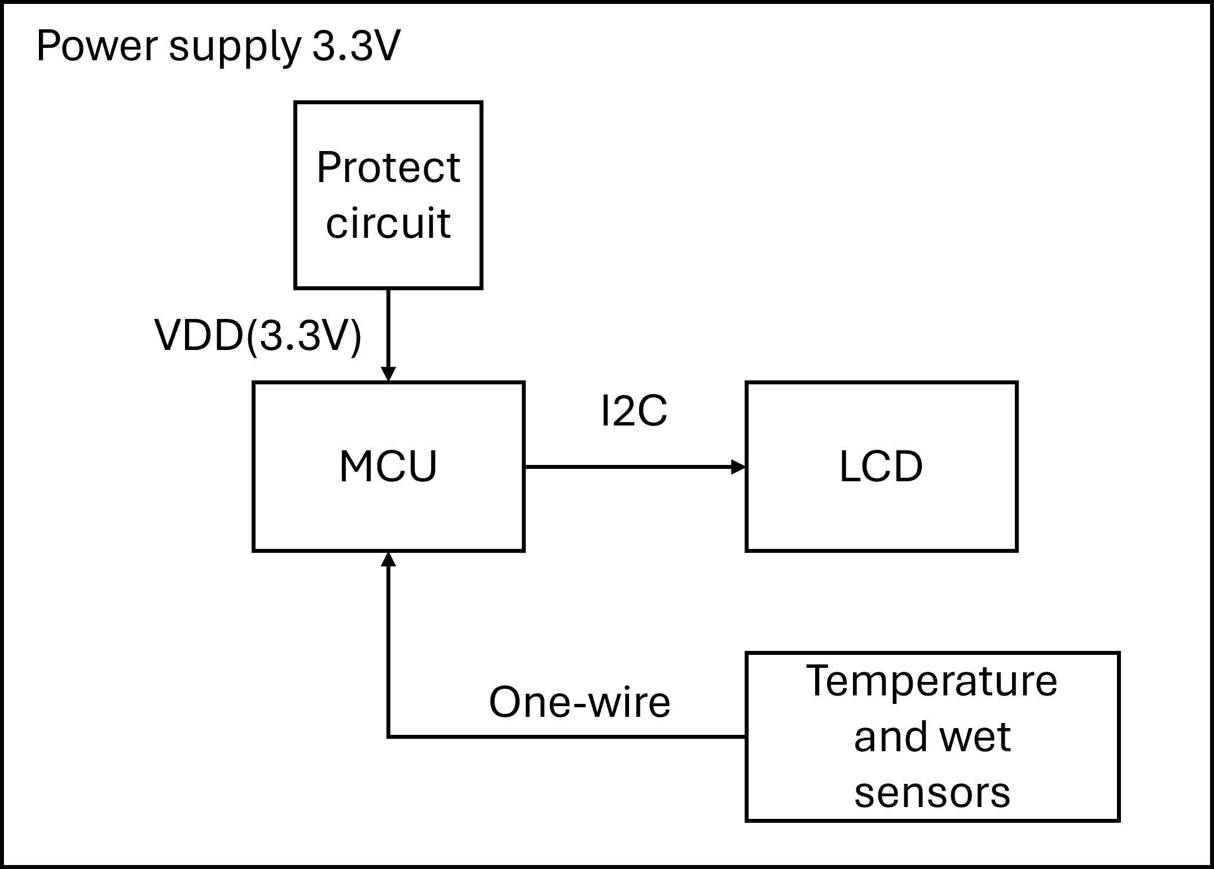

**Figure 2**. Block diagram in concept phase

**II. SETUP CONNECTION AND SIMULATION**

**Figure 3.** Schematic in Kicad

In the ATmega8A-based system, a 3.3V power supply is used to power all components, regulated from a 5V input via an LM7805 linear voltage regulator and a low-pass LC filter for noise reduction. To ensure protection against overcurrent, a 750mA fuse is incorporated into the power line.

For the main microcontroller, the ATmega8A operates at a 16 MHz clock, provided by an external crystal oscillator connected to XTAL1 and XTAL2 pins. A reset push button (SW1) is connected to the RESET pin, allowing manual microcontroller reset.

The temperature and humidity sensors used are two DHT11 modules, which communicate with the MCU through single-wire digital interfaces. Each DHT11 is powered by 5V and includes a pull-up resistor (10kΩ) on the data line to ensure reliable signal transmission.

The user interface is implemented via an I2C LCD module. The LCD is powered by 3.3V and connected to the ATmega8A's I2C-compatible pins: PC4 (SDA) and PC5 (SCL). This enables efficient two-wire communication between the MCU and display for real-time data visualization.

This hardware configuration supports stable operation, clear signal communication, and a cost-effective design, making it suitable for low-power, embedded environmental monitoring systems.

**III. PCB AND PROTOTYPE RESULT**

**Figure 4.** PCB design

**Figure 5.** Prototype result

To check if the temperature and humidity measurement system work right at its function, I test this system at room temperature 25oC

**Figure 6.** Test design at room temperature 25oC

At first test: both sensors are used, temperature display is 26oC, humidity is 63%

**Figure 7.** Design at room temperature 25oC (disconnect primary sensor)

At second test: the primary sensor is taken off, led display: “S1: F” the system uses secondary sensor as alternative, temperature display is 26oC, humidity is 64%

**Figure 8.** Design at room temperature 25oC (disconnect secondary sensor)

During the third test: the secondary sensor is taken off, the system still uses primary sensor, temperature display is 26oC, humidity is 67%

**Figure 9.** Design at room temperature 25oC (disconnect both sensors)

At final test: all sensors are taken off, the led display: “ALL SENSORS FAIL”

**IV. CONCLUSION**

The completion of this project demonstrates the successful design, implementation, and validation of a low-cost embedded system for monitoring temperature and humidity using the ATmega8A microcontroller. The integration of two DHT11 sensors, an I2C LCD module, and a stable power supply illustrates a well-rounded approach to building a reliable and efficient environmental sensing system. The system was tested under various conditions, including sensor failure scenarios, and proved to maintain accurate data output and failover functionality, enhancing its robustness.

Through schematic design, PCB fabrication, and functional prototyping, this project highlights the practical application of embedded system principles, especially in hardware interfacing, power management, and real-time data communication. The use of cost-effective components without compromising performance aligns well with the goals of accessibility and efficiency in embedded design. This project not only fulfilled its technical objectives but also reinforced valuable skills in circuit design, simulation, and embedded firmware development, laying a strong foundation for future advancements in embedded sensor systems.